This patch good for Conductor III Typical Symptoms After June 24, 2022, Data Center Relocation
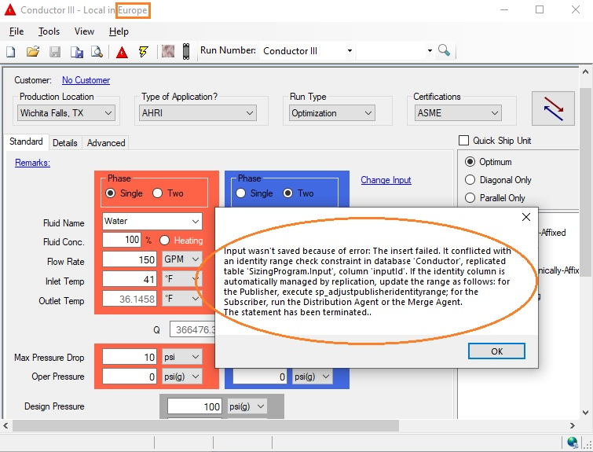
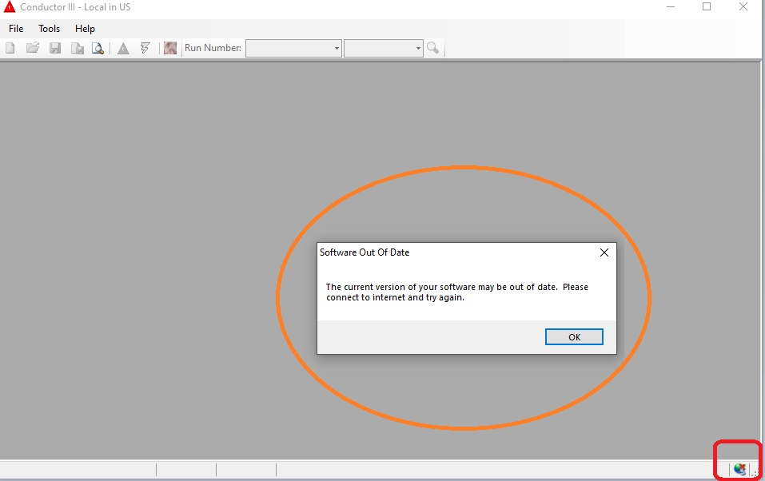

“Tranter CDIII Internal” Usage (07/06/2022, R0.7.5)
Only use this version of Conduct III if you have issue after June 24,2022: our data center renewal.

R0.7.3 Initial Version (07/01/2022 Released) (Fix that User can’t login CDIII after June 24,2022.)
R0.7.4 (07/02/2022 Released) EU Run-Number Saving Issue Temporary Fix Included. (--region=eux)
(What was changed: Rerouting ‘HxSizingProgramIOService’ From EU to US temporarily.)
It can be used until Regional Conduct-III Database Merged Subscription completed or later.
R0.7.5 (07/06/2022 Released) WAN, REPs, Public Internet connectable.

0. Original CDIII Must NOT be reinstalled if installed previously. SKIP this part if installed already. Please NEVER UNINSTALL the previous Conductor III because this is a service pack!
Original CDIII must be installed first if not installed previously. To install the original CDIII, =>

Please use the following links to setup if client is in our intranet. Ask us the CDIII setup instruction if needed.
http://wfsws01.tcn.local/install/ConductorIII/3.0.0.257/CDIIISetup.exe
http://websync.tranter.com/install/ConductorIII/3.0.0.257/CDIIISetup.exe

http://wfsws01.tcn.local/install/ConductorIII/Mininstallversion/CDIIISetup.exe
http://websync.tranter.com/install/ConductorIII/Mininstallversion/CDIIISetup.exe

1. Install Conduct III Internal R0.7.5 Use one of the following installers.

(Default) CD3IntSetupR0.7.5 … precompiled as US
https://mega.nz/file/21AHVAYa DecryptKey=> hhZaar28XdArIdP1pcvioMgdpKKXWy7N1htDGChf9sU

(Default EU, Saving Run-Number Issue Temporary Fix) CD3IntSetupR0.7.5EUX
https://mega.nz/file/mhZyAAZJ DecryptKey=> UQC3SYxXQwFbNakZX1QLx0nd3T_04hvWgv6IH-I14fQ

(Default China) CD3IntSetupR0.7.5China
https://mega.nz/file/ykJxwLrI DecryptKey=> UrbNlgCz5q4nut2MiS1CAzvN3iYcLs8hn0uxzy7N-X4

(Default India) CD3IntSetupR0.7.5India
https://mega.nz/file/Ctx2DBCB DecryptKey=> HsZ-jjwx5DPk4Haon9wp7Uin3xPwT3K8SPrl5UAEay4
Confirm it is installed correctly by Fig 1.0

(Default EU, No EU Saving Run-Number Issue Fix) CD3IntSetupR0.7.5EU
https://mega.nz/file/zgYkULzK DecryptKey=> z10nEo6k-XFmm_BvAj40tmXmqrCJFJSrq_cYTMjtthU

All above five installers are identical except a different command line program run option.

2. Run “Tranter CDIII Internal” by the one of the following methods
1) Fig 2.0 2) Fig 3.0 3) Fig 4.0

3. User can change freely the region of database as Fig 5.0

Fig 1.0 Windows Control, Program list after the correct installation of Tranter Group Internal package
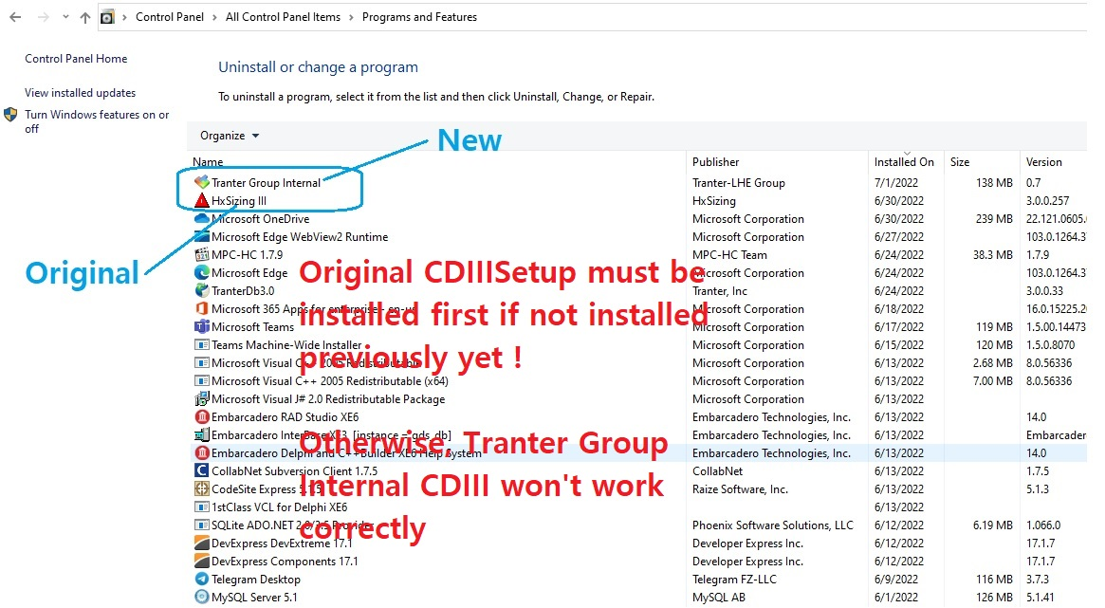

Fig 2.0 Run it by desktop icon (‘run as administrator’ is recommended)
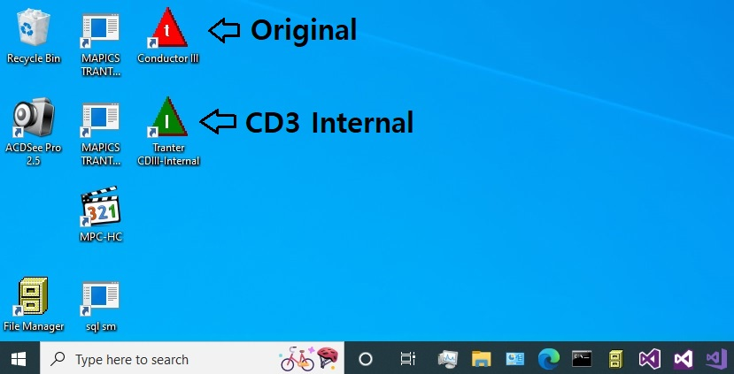
Fig 3.0 Run it by Windows Startup Menu 1 (‘run as administrator’ is recommended)
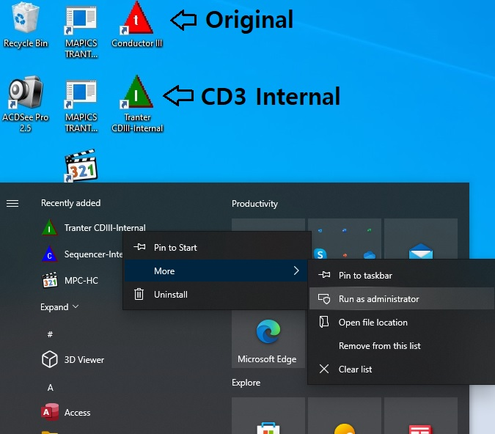

Fig 4.0 Run it by Windows Startup Menu 2 (‘run as administrator’ is recommended)
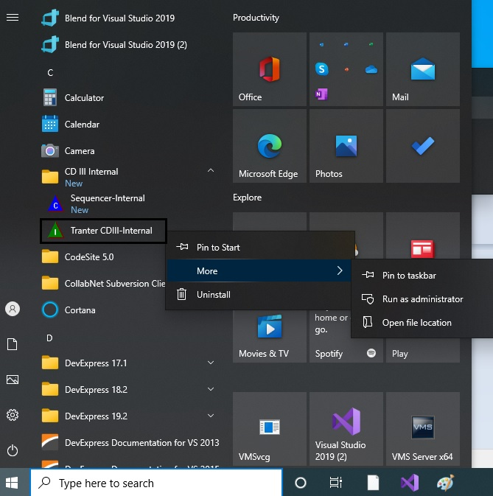

Fig 5.0 How to change the default region from US to China, India, or EU.
--region=us, --region=ch, --region=in, --region=eu, --region=eux (save issue fix)
