This patch good for Conductor III Typical Symptoms After June 24, 2022, Data Center Relocation

“Tranter CDIII Internal” Usage (08/08/2022, R0.7.51)

R0.7.3 Initial Version (07/01/2022 Released) (Fix that User can’t login CDIII after June 24,2022.)

R0.7.4 (07/02/2022 Released) EU Run-Number Saving Issue Temporary Fix Included. (--region=eux)

(What was changed: Rerouting ‘HxSizingProgramIOService’ From EU to US temporarily.)

It can be used until Regional Conduct-III Database Merged Subscription completed or later.

R0.7.5 (07/06/2022 Released) WAN, REPs, Public Internet connectable.

R0.7.51 (08/08/2022 Released) Sequence Program Conductor IV V2 CDIVProgramIO support.

**0. Original CDIII Must NOT be reinstalled if installed previously. SKIP this part if installed already. Please NEVER UNINSTALL the previous Conductor III because this is a service pack!**

**Original CDIII must be installed first if not installed previously. To install the original CDIII, =>**

Please use the following links to setup if client is in our intranet or Internet. Ask us the CDIII setup instruction if needed.

<http://sync-na.hxsizing.com/install/ConductorIII/>

**1. Install Conduct III Internal R0.7.51 Use one of the following installers.**

<http://sync-na.hxsizing.com/install/ConductorIII/CD3InternalPatch/0.7.51/>

**(Default)** CD3IntSetupR0.7.51 … precompiled as US

**(Default EU, Saving Run-Number Issue Temporary Fix)**CD3IntSetupR0.7.51EUX

**(Default China)** CD3IntSetupR0.7.51China

**(Default India)** CD3IntSetupR0.7.51India

**(Default EU, No EU Saving Run-Number Issue Fix)** CD3IntSetupR0.7.51EU

All above five installers are identical except a different command line program run option.

**2. Run “Tranter CDIII Internal” by the one of the following methods**

1) Fig 2.0 2) Fig 3.0 3) Fig 4.0

**3. User can change freely the region of database as Fig 5.0**

Fig 1.0 Windows Control, Program list after the correct installation of Tranter Group Internal package

Fig 2.0 Run it by desktop icon (‘run as administrator’ is recommended)

Fig 3.0 Run it by Windows Startup Menu 1 (‘run as administrator’ is recommended)

Fig 4.0 Run it by Windows Startup Menu 2 (‘run as administrator’ is recommended)

Fig 5.0 How to change the default region from US to China, India, or EU.

--region=us, --region=ch, --region=in, --region=eu, --region=eux (save issue fix)

**4. Run “Sequence Internal V2” as below**

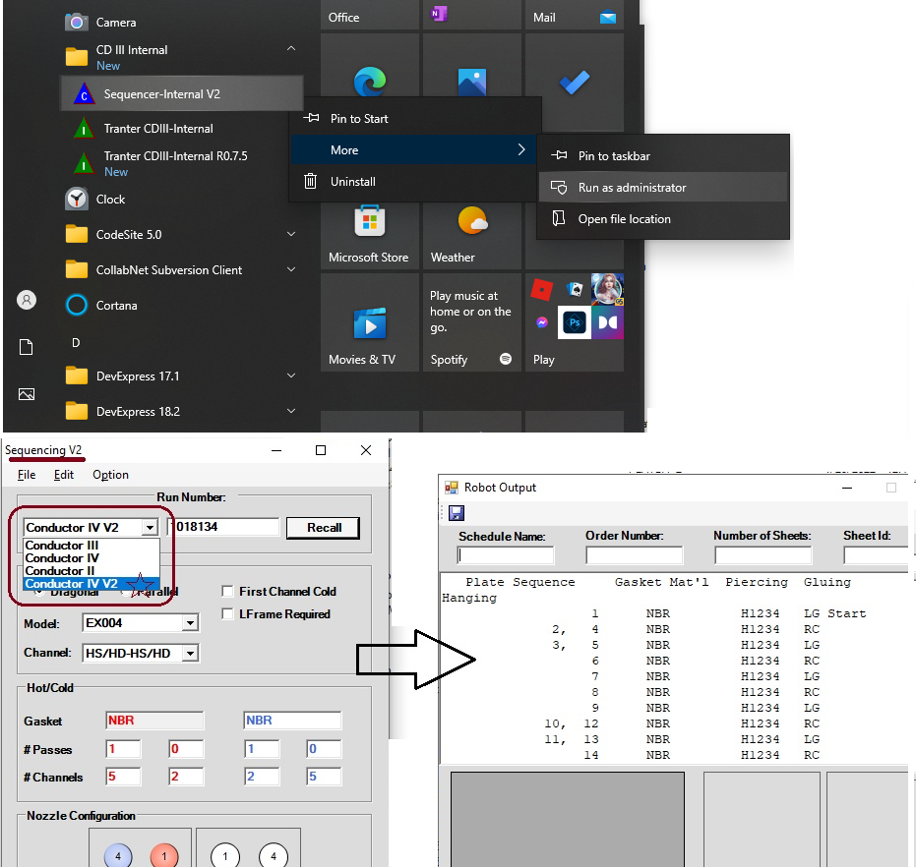

**Remark: Sequence Internal V2 is identical to existing Sequence program except the new**

**CDIVProgramIO Service Pointer.**